Applicability domain of the dataset
S1.1 Motivation and Methods
Because the dataset comprises only ten samples from a single source, the region of descriptor space within which the reported conclusions are valid should be stated explicitly. Three complementary diagnostics were computed from the descriptor matrix, no model inference is involved. First, the four descriptors (PD, CA, T, P) were autoscaled (zero mean, unit variance) and subjected to principal component analysis (PCA). The score plot of the first two components, which jointly explain 82.0% of the descriptor variance (PC1: 57.7%; PC2: 24.3%), together with the convex hull of the ten scores, visualises the global coverage of the sampled design space (Figure S1a). Second, to diagnose the interpolation/extrapolation character of every LOOCV fold, the leverage of each held-out sample was computed with respect to its nine training samples, Following common chemometric practice, a warning threshold of h* = 3p/n_train = 1.33 (p = 4 descriptors, n_train = 9) was adopted (Figure S1b). Third, a range check recorded, for every fold, whether the held-out value of each descriptor fell outside the minimum–maximum interval of the corresponding training set, and by what percentage of the training range (Figure S1c).

Table S1. Descriptor and target statistics of the ten-sample PSF membrane dataset.
Variable | Min | Max | Mean | SD | CV (%)
PD (µm) | 0.298 | 0.842 | 0.451 | 0.162 | 36.0
CA (°) | 66.4 | 94.6 | 81.80 | 9.74 | 11.9
T (mm) | 0.136 | 0.273 | 0.195 | 0.041 | 21.1
P (%) | 69.09 | 79.16 | 75.43 | 3.63 | 4.8
E (N/mm²) | 90.18 | 235.65 | 158.90 | 49.83 | 31.4
TS (N/mm²) | 3.97 | 9.65 | 6.62 | 2.00 | 30.2
EL (%) | 42.07 | 69.04 | 55.46 | 10.20 | 18.4
SD: standard deviation (n-1), CV: coefficient of variation = SD/mean×100.

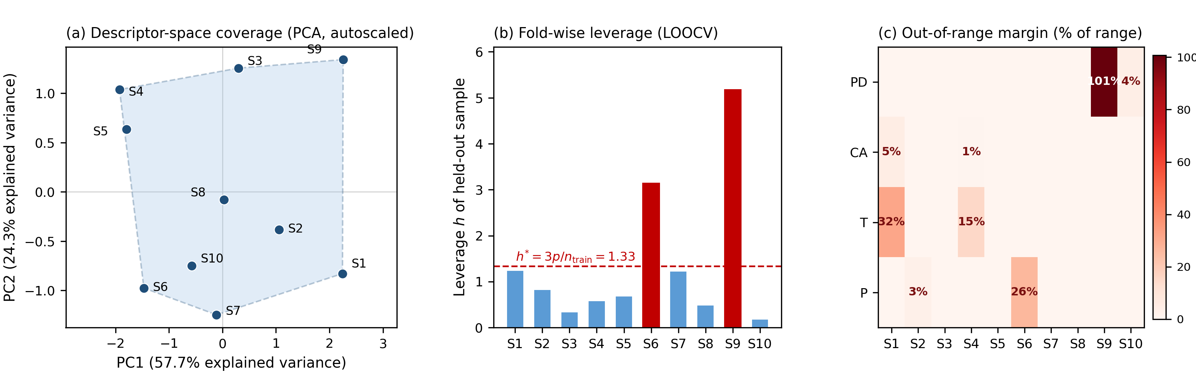
Figure S1. Applicability domain of the ten-sample dataset. (a) PCA score plot of the autoscaled descriptors with the convex hull of the sampled region. (b) Fold-wise leverage of each LOOCV held-out sample with respect to its nine training samples. (c) Out-of-range margin of each held-out descriptor value, expressed as a percentage of the corresponding training range (blank cells: within range).

S1.2 Results and Discussion
The descriptor and target statistics are summarised in Table S1. The ten samples span PD = 0.298 - 0.842 µm, CA = 66.4 - 94.6°, T = 0.136 - 0.273 mm, and P = 69.09 - 79.16%, with coefficients of variation between 4.8% (P) and 36.0% (PD). The PCA score plot shows the ten samples distributed across the hull without a collapsed direction in the first two components. The fold-wise diagnostics quantify the unavoidable difficulty of LOOCV at n = 10: two folds exceeded the leverage warning threshold, namely S6 (h = 3.14, driven by the lowest porosity, lying 26% of the training range below the training minimum) and, most prominently, S9 (h = 5.18, whose pore diameter of 0.842 µm lies 101% of the training range above the training maximum of 0.569 µm). All remaining folds were interpolative or near-boundary (h≤1.25).
These diagnostics serve two purposes. First, they delimit the applicability domain: the conclusions of the main text apply within the descriptor ranges of Table S1, and any use of either modelling branch outside this region constitutes extrapolation. Second, they contextualise the error topology reported in Sections 3.4 - 3.5 of the main text. The two high-leverage folds coincide exactly with the folds in which the PLS baseline exhibited its largest deviations (the S9-specific overestimation of E and TS, and the large run-to-run dispersion at S6 for EL), whereas the LLM predictions remained close to the experimental values with narrow run-to-run spread on these same folds.
The magnitude-dependent, regression-to-the-mean bias shared by all models at the domain edges is likewise consistent with the mild extrapolation revealed by the range check. The applicability-domain analysis therefore supports the interpretation that the comparative advantage of the LLMs emerges most clearly on extrapolative folds, while underscoring that absolute predictive accuracy outside the sampled domain remains untested.

